A&L Engineering

Supply Drop Plan

DIAGRAM

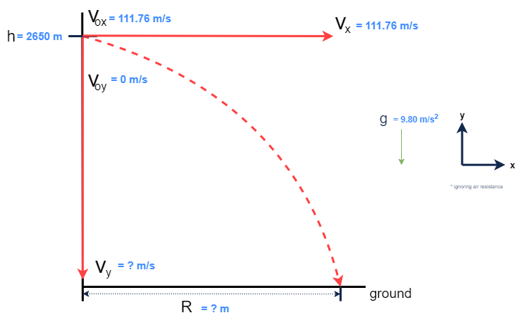

INITIAL CALCULATIONS

Converting to S.I. units:
$v_{0x}$ = $250\frac{mi}{hr}*\frac{1609.44 m}{1 mi}*\frac{1hr}{60 min}*\frac{1 min}{60 s}=111.76\frac{m}{s}$ $≅112\frac{m}{s}$

Final Horizontal Velocity: (Constant horizontal velocity, ignoring air resistance):
${v_{x}=v}_{\begin{aligned}0x \\ \end{aligned}}=111.76 \frac{m}{s}$

Time in Air:

$h = h_{0} + v_{0y}·t +\frac{ 1}{2}·a·t^{2}$
$$2650 m = 0 + 0·t +\frac{1}{2}·g·t^{2}$$
$$2650 m =\frac{1}{2} · 9.80 \frac{m}{s^{2}} · t^{2}$$
$$2650 m =4.90 \frac{ m}{s^{2}} · t^{2}$$
$$t = \sqrt{\frac{2650 m}{\frac{4.90 m}{s^{2}}}}$$
$$t≅23.255458 s≅23.255 s$$

Final Vertical Velocity:
$$v_{y} = v_{0y} + a·t = 0 +9.80\frac{ m}{s^{2}} · 23.255458 s≅227.903488 \frac{m}{s}≅227.90 \frac{m}{s}$$

Final Total Velocity:
$$v= \sqrt{{v_{y}}^{2} + {v_{x}}^{2}}=\sqrt{\left({\left(227.903488\frac{m}{s}\right)}^{2}+ {\left(111.76\frac{m}{s}\right)}^{2}\right)}≅253.831238 \frac{m}{s}≅253.83 \frac{m}{s}$$

Horizontal Drop Distance:
$$R = v_{0x} + v_{x}·t = 0 + 111.76 \frac{m}{s} · 23.255 s = 2598.9788 m≅2599.0 m$$

Description

$$v_{0x}=initial horizontal velocity (\frac{m}{s})$$
$v_{0y}=initial vertical velocity \left(\frac{m}{s}\right)$
$v_{x}= final horizontal velocity (\frac{m}{s})$
$v_{y}=final vertical velocity \left(\frac{m}{s}\right)$
v = final total velocity $\left(\frac{m}{s}\right)$
a = acceleration = g = 9.80 $\frac{m}{s^{2}}$
t = time payload is in the air once dropped (s)
h = height to drop payload (m)
R = horizontal distance from target (m)

In Kinematics, horizontal and vertical motion are independent of each other, but they do have a relationship via time. In projectile motion of a free-falling object, the greater the amount of time in the air, the greater the final vertical velocity. With no air resistance, the horizontal velocity is constant.

The total (final) velocity can be found with the Pythagorean Theorem:

$v = \sqrt{{v_{x}}^{2} + {v_{y}}^{2}}$

MODIFIED SCENARIO ONE

Diagram

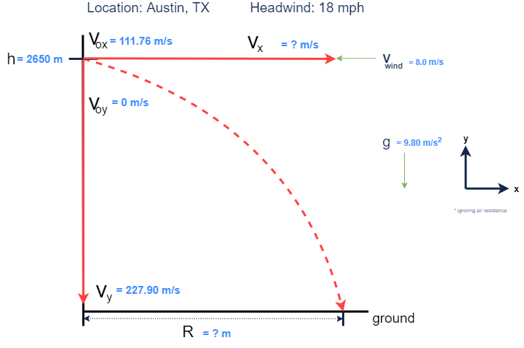

Source: National Oceanic and Atmospheric Administration.

“National Weather Service”.7/22/2022, https://www.weather.gov

Description

Converting to S.I. units:
$v_{wind}$ = -$18\frac{mi}{hr}*\frac{1609.44 m}{1 mi}*\frac{1hr}{60 min}*\frac{1 min}{60 s}=8.0472\frac{m}{s}$ $≅8.0\frac{m}{s}$

Head wind only affects horizontal motion, so:
$$v_{y}≅227.90\frac{m}{s} AND t=23.255 s$$
Adjusted horizontal velocity:
$v_{x}$ = $v_{0x}-v_{w}=111.76\frac{m}{s} - 8.0472\frac{m}{s}=103.7128\frac{m}{s}≅103.71\frac{m}{s}$

Horizontal distance should be less at a slower horizontal velocity:
$R= v_{x} ·t=103.71\frac{m}{s} ·23.255 s=2411.77605 m≅2411.8 m$

The 18 mph (or 8.0 m/s) headwind caused the horizontal velocity to decrease; however, no change occurred to the vertical motion. The decreased horizontal velocity requires a smaller horizontal distance from 2599.0 m in the original plan to 2411.8 m in this scenario.

MODIFIED SCENARIO TWO

Diagram
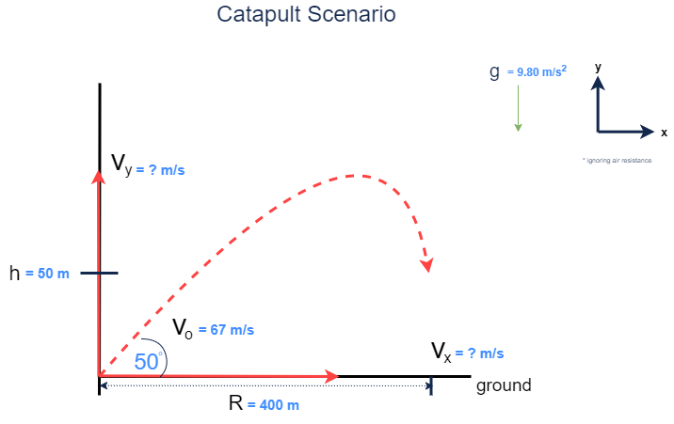

Description

Final vertical velocity:
$$v_{y}= v_{0y}·sin θ=67\frac{m}{s}·\sin{50}°≅51.3249777≅51\frac{m}{s}$$

Final horizontal velocity (ignoring air resistance):
$$v_{x}= v_{0x}·cos θ=67\frac{m}{s}·\cos{50}°≅43.0667698≅43\frac{m}{s}$$

Air-Time:
$t =\frac{ R}{v_{x}}=$ $\frac{400 m }{43.0667698 \frac{m}{s}}≅9.28790345≅9.3 s$

Vertical height:
H = $v_{y}·t+\frac{1}{2}at^{2}=51.3249777\frac{m}{s}·9.28790345 s+\frac{1}{2}\left(-9.8\frac{m}{s^{2}}\right)\left(9.28790345^{2}\right)=54.0022 m≅54 m$
- 54 m > 50 m, so the payload will reach (and pass) the target site

Changing the starting velocity or angle of the catapult would alter the distance needed to reach the target site. A lower velocity or a steeper (larger) angle (relative to the horizontal plane) would be more precise, in this case.

